1A Unit2 New friends (Period 1)
Class________ Name_________ Number_______
一、Listen and choose. (听录音，圈出正确的图片。)
1. a.  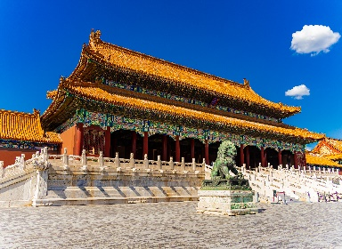 | b.  
Hello!! | Hi!
- a.   | b.  
3.a.   | b.  

二、Listen and judge.(听录音，判断下面的图片是否正确，正确的用“√”表示，错误的用“×”表示。)

1. 2.
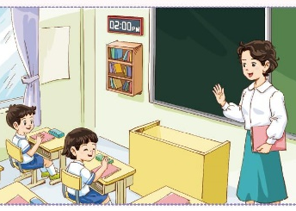

3. 4.




三、Read and circle.(读一读，在表格中圈单词。)
hi hello name welcome friend

n | o | h | i | h | l | p | b | h | j
h | e | l | l | o | h | o | l | e | N
b | a | n | e | d | e | n | a | m | e
a | w | e | l | c | o | m | e | e | n
f | l | i | f | r | i | e | n | d | s

四、Look and circle. (看图，圈出与图片相符的内容)
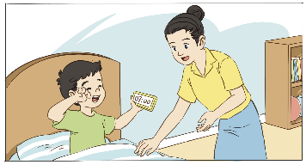
1. a. Good morning, Mum.
b. Goodbye, Mum.
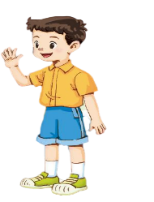
2. a. I’m Minmin.
b. I’m Xiaopu.


3. a. Hello!
b. Goodbye!

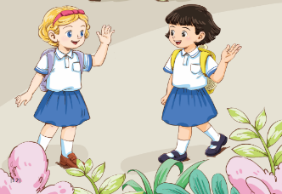
4. a. Nihao, Shenshen.
b. Sorry, Shenshen.

附：听力内容
一、Listen and choose. (听录音，圈出正确的图片。)
1. Welcome to Shanghai. (b)
2. Hello! (a)
3. Hi, I’m Lily. (b)
二、Listen and judge.(听录音，判断下面的图片是否正确，正确的用“√”表示，错误的用“×”表示。)
1. Good morning, class. (×)
2. Welcome to China. (√)
3. ---Nihao! I’m Lily White. (√)
---Hello, Lily.
4. Hi, I’m Xiaotian. Nice to meet you. (×)

1A Unit2 New friends
(Period 2)
Class________ Name_________ Number_______
- Listen and choose. (听录音，选出听到的句子。)
1. a. Hi, Shenshen. b. Hi, I’m Shenshen.
2. a. Hello, Lily. b. Hello, my name is Lily.
3. a. Good evening. b. Good afternoon.
4. a. Welcome to China. b. Welcome to London.

二、Listen and circle. (听录音，圈答句。)
1. a. Hello, Xiaopu. b. Hello, Xiaotian.
2. a. Good morning. b. Good afternoon.
3. a. I’m fine, thank you. b. Nice to meet you too.
4. a. Good evening, Dad. b. Goodbye, Dad.

三、Read and match.(读句子，将句子与图片连线。)
1. Hello! My name is Shenshen. a.

2. Hi! My name is Lily White. b.


3. I’m Minmin. c.


4. I’m Xiaopu. d.

四、Read and circle. (看图读对话，圈出正确的句子。)
a. Hi, Miss Li.
b. Hi, Lily. I’m Miss Li.

a. Hello, my name is Lily.
b. Hello, I’m Shenshen.

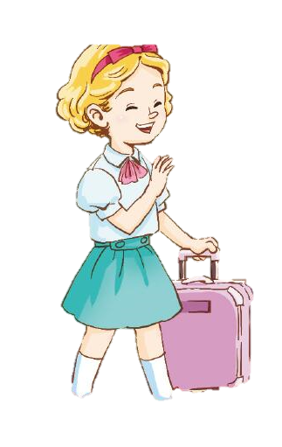
a. Welcome to China.
b. Welcome to London.
a. Nice to meet you, Miss Li.
b. Nice to meet you, Ms Yu.

附: 听力内容
一、Listen and choose. (听录音，选出听到的句子。)
1. Hi, Shenshen. (a)
2. Hello, my name is Lily. (b)
3. Good evening. (a)
4. Welcome to London. (b)
二、Listen and circle. (听录音，圈答句。)
1. Hello, I’m Xiaopu. (a)
2. Good afternoon. (b)
3. Nice to meet you too. (b)
4. Goodbye, Shenshen. (b)

